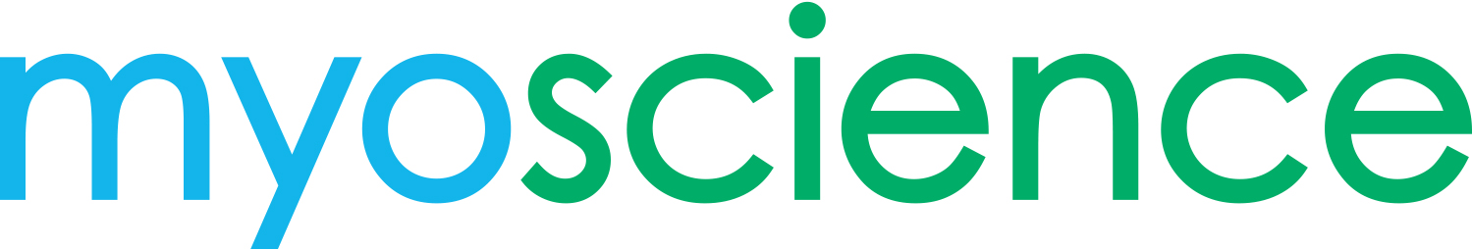

INVESTIGATOR-INITIATED RESEARCH PROGRAM

Goal

The goal of the Investigator-Initiated Research (IIR) Program is to advance knowledge and understanding of the iovera° system in the treatment of peripheral nerves through research that is initiated, designed and implemented by external investigators.

IIR Program

The myoscience Investigator-Initiated Research Program is open to all academic and community-based physicians and researchers in the United States who are interested in conducting their own research. Support is provided based on the scientific merit of the proposal as well as whether it is in alignment with myoscience areas of interest.

IIR proposals may include:
- Prospective and retrospective clinical studies of approved and unapproved uses related to iovera° device
- Health outcomes research pertinent to the disease states treated by the iovera° device

Please note that myoscience is not the sponsor of these studies, and they are ancillary to the myoscience clinical development program. Studies will be supported in the form of study supplies at reduced or no cost or funding for clinical or basic research. The generated results will be properly disseminated in peer-reviewed posters, presentations, abstracts and/or publications.

Interested investigators may contact myoscience to receive the proposal packet which includes additional information about the IIR program, a proposal application (requiring site details, a proposed study summary and a proposed study budget) as well as a sample proposal. The proposal will be reviewed and the investigator contacted within 4 weeks or proposal receipt. If the proposal is selected for support the Research department will contact the investigator to finalize any details or questions related to the conduct of the study before the study commences.

Contact Information

If you would like more information about the IIR program or would like to discuss or submit a proposal please contact:

Jessica Preciado, PhD
650-421-0665
research@myoscience.com

