OB -End of life pregnant woman: Who decides care for “end of life” pregnant woman relative to life of the unborn child?
When pregnant woman becomes a qualified end of life patient (ex: terminal disease/ less than 6 months to live/ or in persistent non cognitive/ permanent comatose state) & unable to make her own decisions & has not made a declaration previously to lacking capacity.
…Decision relative to life of unborn child rests with classes of family members designated in family default consent law. See bold type infra @ LRS 40:1151.9E
LRS 40§1151.9. General application
A. Nothing in this Subpart shall be construed to condone, authorize, or approve assistance to suicide, mercy killing, or euthanasia; or to permit any affirmative or deliberate act or omission to end life other than to permit the natural process of dying.
B.(1) The withholding or withdrawal of life-sustaining procedures from a qualified patient in accordance with the provisions of this Subpart shall not, for any purpose, constitute a suicide.
(2) Nor shall the making of a declaration pursuant to this Subpart affect the sale, procurement, or issuance of any life insurance policy, nor shall it be deemed to modify the terms of an existing policy.
(3) No policy shall be legally impaired or invalidated by the withholding or withdrawal of life-sustaining procedures from an insured, qualified patient, notwithstanding any term of the policy to the contrary.
(4) A person shall not be required to make a declaration as a condition for being insured or for receiving health care services.
(5) The removal of life support systems or the failure to administer cardio-pulmonary resuscitation under this Subpart shall not be deemed the cause of death for purposes of insurance coverage.
C. The provisions of this Subpart are cumulative with existing law pertaining to an individual's right to consent or refuse to consent to medical or surgical treatment.
D. A declaration properly executed in and under the laws of another state is deemed to be validly executed for purposes of this Subpart.
E. It is the policy of the state of Louisiana that human life is of the highest and inestimable value through natural death. When interpreting this Subpart, any ambiguity shall be interpreted to preserve human life, including the life of an unborn child if the qualified patient is pregnant and an obstetrician who examines the woman determines that the probable post fertilization age of the unborn child is twenty or more weeks and the pregnant woman's life can reasonably be maintained in such a way as to permit the continuing development and live birth of the unborn child, and such determination is communicated to the relevant classes of family members and persons designated in R.S. 40:1151.4. (Default family decision makers when patient lacks capacity)
Acts 1984, No. 382, §1; Acts 1990, No. 749, §1; Acts 1999, No. 641, §1, eff. July 1, 1999; Acts 2005, No. 447, §1; Acts 2012, No. 715, §1; Acts 2014, No. 850, §1, eff. June 23, 2014; Redesignated from R.S. 40:1299.58.10 by HCR 84 of 2015

Recall Pulmonary Medicine Health Law slides
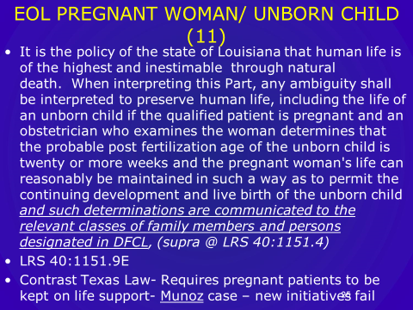

Contrast- Texas law requires pregnant patients to be kept on life support- even against family’s wishes- until birth of child)
EX: Marlie Munz- 14 weeks pregnant collapsed pulmonary embolism and was kept on life support against family wishes… In that case Texas Court allowed withdraw of life support prior to birth of child- because Mrs Munz had been declared dead…ruling law did not include life support for the dead.

