When Imaging is Negative but Infection Persists: Abdominal Wall Abscess Linked to CGM Sensor
Sarah Hemelt, BS¹; Jordan Ward, MD²; Mary Katherine Moore, MD³; Victoria Burke, MD⁴; Hope Oddo Moise, MD³; Nicholas Culotta, MD²; Jordan Callender, MD³
¹LSU Health Sciences Center School of Medicine, ²LSU Health Sciences Center New Orleans, Department of Dermatology, ³LSU Health Sciences Center New Orleans, Department of Medicine, ⁴LSU Health Sciences Center New Orleans, Department of Infectious Disease

Introduction
- Continuous glucose monitoring (CGM) devices are increasingly used in diabetes management and are generally well tolerated.
- Cutaneous complications are most often allergic or irritant contact dermatitis; infectious complications are uncommon but potentially severe.
- Reported infectious complications include cellulitis, abscesses, and rarely necrotizing soft tissue infections.
- Imaging modalities such as CT and ultrasound are frequently used to evaluate soft tissue infections, but sensitivity is not 100%, especially in atypical or deep infections.
- Negative imaging should not preclude further investigation in patients with progressive or refractory infection.
- We present a case of a CGM-associated abdominal wall abscess with initially negative imaging and delayed surgical diagnosis.

Figures
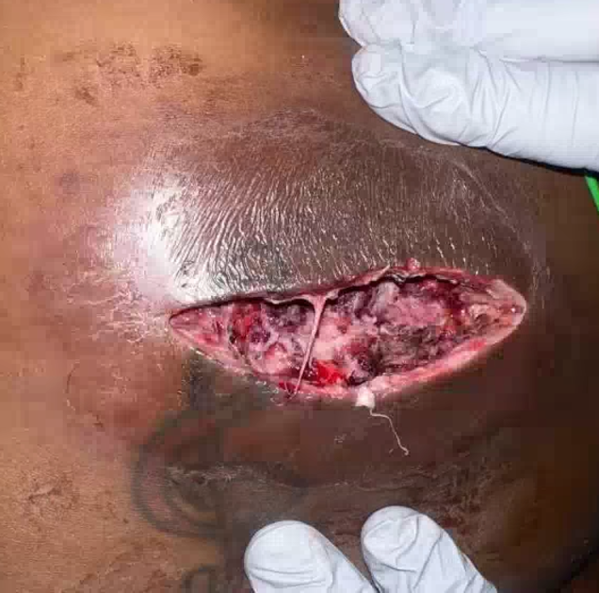
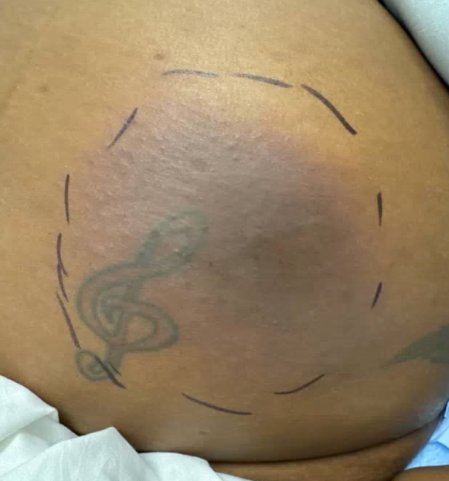
- Cutaneous complications of CGM devices are most commonly irritant or allergic contact dermatitis; infectious complications are less frequently reported.
- Severe device-associated infections including necrotizing soft tissue infection have been described, though they are rare.
- This case demonstrates a deep, walled-off abscess not detected by CT or ultrasound despite progressive clinical deterioration.
- Prior studies suggest ultrasound sensitivity of approximately 96.7% compared to CT sensitivity of approximately 76.7% for superficial abscess detection.
- Meta-analytic data show point-of-care ultrasound sensitivity of approximately 93.5% and specificity of approximately 89.1% for abscess detection.
- Despite strong overall diagnostic performance, imaging can fail to identify complex, deep, or evolving abscesses.
- This case highlights the limitations of relying on imaging alone in the evaluation of refractory cellulitis.
- Persistent clinical worsening should prompt reconsideration of the diagnosis and pursuit of alternative diagnostic or therapeutic approaches.
- Bedside diagnostic procedures such as punch biopsy may serve both diagnostic and therapeutic roles.
- Multidisciplinary collaboration between dermatology, surgery, and infectious disease was critical in achieving definitive source control.

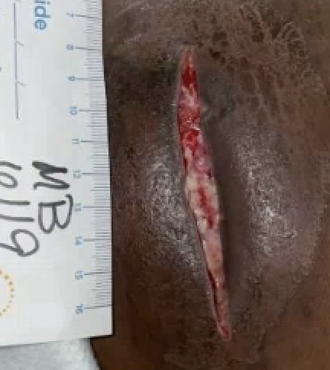
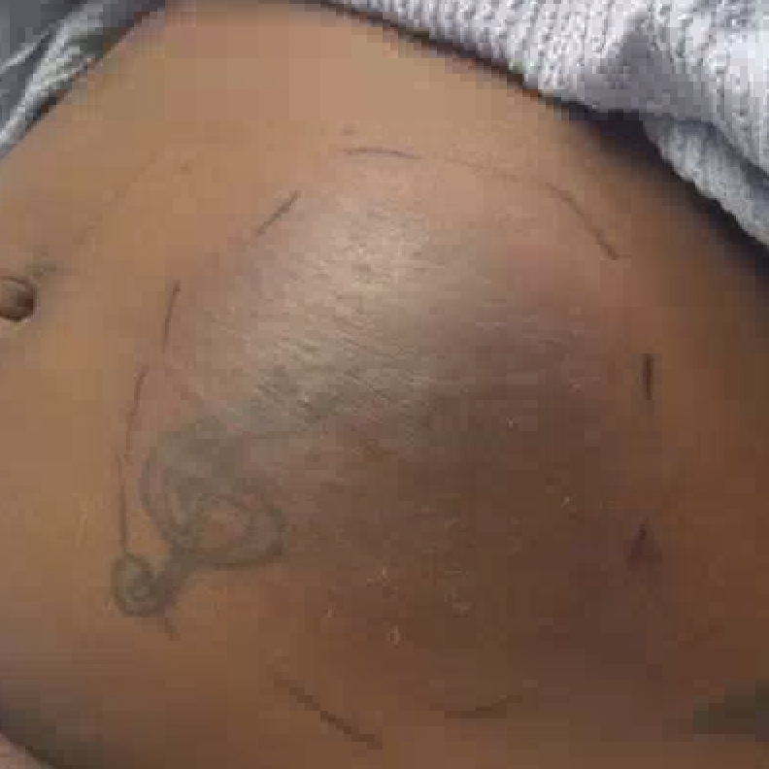

Fig 1 (top left): Left mid-abdominal wall on hospital day 4
Fig 2 (bottom left): Left mid-abdominal wall on hospital day 6 prior to biopsy
Fig 3 (top right). Left mid-abdominal wall on hospital day 8 status post operative debridement
Fig 4 (bottom right): Left mid-abdominal wall on hospital day 13

Discussion

Case Report Conclusion



- 32-year-old woman with poorly controlled type 2 diabetes mellitus (A1c 12.4%), hyperlipidemia, polycystic ovary syndrome, and asthma.
- Presented with progressive erythema, pain, and induration at the CGM insertion site on the left abdominal wall.
- Treated outpatient with oral antibiotics for presumed cellulitis without improvement and subsequently admitted with sepsis.
- Serial CT and targeted ultrasound demonstrated cellulitis without evidence of abscess or drainable fluid collection.
- Despite broad-spectrum intravenous antibiotics, erythema, pain, and induration continued to worsen.
- Surgical consultants initially deferred intervention due to lack of imaging evidence of abscess.
- On hospital day 6, dermatology performed a punch biopsy which immediately released copious purulent drainage.
- Surgery was emergently consulted and performed bedside incision and drainage, followed by operative debridement with wound vacuum placement the following day.
- Wound cultures grew Streptococcus anginosus, Parvimonas micra, Candida guilliermondii, and Campylobacter curvus.
- The patient improved after surgical source control and targeted antimicrobial therapy.
- She was discharged in stable condition after a 17-day hospitalization.

- CGM-associated infections are uncommon but can be severe and life-threatening.
- Negative imaging does not exclude the presence of an abscess in a clinically worsening patient.
- Clinical progression should take precedence over radiographic findings in decision-making.
- Early multidisciplinary involvement and timely source control are essential for optimal outcomes.

References
1. Asarani, N. A. M., Reynolds, A. N., Boucher, S. E., de Bock, M., & Wheeler, B. J. (2020). Cutaneous Complications With Continuous or Flash Glucose Monitoring Use: Systematic Review of Trials and Observational Studies. Journal of diabetes science and technology, 14(2), 328–337. https://doi.org/10.1177/1932296819870849
2. Von Tokarski, F., Hobson, C., Lartigue, M. F., Lemaignen, A., & Lioger, B. (2021). Streptococcus pyogenes necrotizing soft tissue infection following glucose monitoring with FreeStyle Libre device. QJM : monthly journal of the Association of Physicians, 114(1), 58–59. https://doi.org/10.1093/qjmed/hcaa123
3. Gaspari, R. J., Dayno, M., Briones, J., & Blehar, D. (2012). Comparison of computerized tomography and ultrasound for diagnosing soft tissue abscesses. Critical Ultrasound Journal, 4(1), 5. https://doi.org/10.1186/2036-7902-4-5
4. Gottlieb, M., Avila, J., Chottiner, M., & Peksa, G. D. (2020). Point-of-Care Ultrasonography for the Diagnosis of Skin and Soft Tissue Abscesses: A Systematic Review and Meta-analysis. Annals of emergency medicine, 76(1), 67–77. https://doi.org/10.1016/j.annemergmed.2020.01.004

